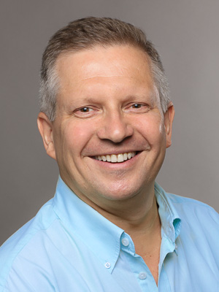
IT-Skills

Senior Software Engineer - Java
Address Seydelstraße 23
10117 Berlin
E-Mail mp@empec.de
Web www.empec.de

Operating systems
Linux
Windows
macOS

Development tools
IDEA IntelliJ
Eclipse

Languages / Frameworks
Java 17,
Spring, Spring Boot

Databases
Oracle
DB2
PostgreSQL
mySQL
H2

Architectures
Event driven architecture
Hexagonal architecture
Domain driven design

Technologies
MVC
CDI
REST
AMQP
Scrum, Kanban
Test driven development

Cloud
Amazon AWS
Docker, docker compose
Kubernetes

Tools
JIRA
Confluence
MS-Office

Build tools
Maven
Ant

Version control / CI
git
SVN
CVS
GitLab CI

Components
JPA / Hibernate
Querydsl, Criteria AP
Spring DataI
HQL, JPQL, SQL
Log4J, SLF4J, Logstash
RabbitMQ
Kafka
Quartz
MinIO
Redis
Jackson
Swagger, OpenAPI
MapStruct
Lombok
Feign
Resilience4J
AOP, AspectJ
Micrometer
Prometheus, OpenTracing
Kibana, Grafana, Jaeger
JUnit, AssertJ, Mockito
Testcontainers

Special knowledge

Languages
Deutsch: native language
Englisch: good in speech and writing

Certificates
Sun Certificated Programmer for the Java 2 Platform 1.4

